Classifying Gait Behavior in Children and Adolescents: A Multiple Regression Approach Using Cadence to Predict the Walk-to-Run Transition

Scott W. Ducharme1, Dusty S. Turner2, James D. Pleuss2, Aston K. McCullough1, Christopher C. Moore1, John M. Schuna Jr3, Diana M. Thomas2, Catrine Tudor-Locke1*, & Elroy J. Aguiar1

*1Physical Activity & Health Laboratory, Department of Kinesiology, University of Massachusetts-Amherst, Amherst, Massachusetts*

*2Department of Mathematical Sciences, United States Military Academy-West Point, West Point, New York*

*3School of Biological and Population Health Sciences, Oregon State University,*

*Corvallis, Oregon*

**\*Corresponding author:**

Catrine Tudor-Locke, PhD, FNAK, FACSM

Department of Kinesiology

University of Massachusetts Amherst

160A Totman Building

30 Eastman Lane

Amherst, MA, 01003

Phone: +1 413 545 1583

Email: [ctudorlocke@umass.edu](mailto:ctudorlocke@umass.edu)

# Abstract

**Background:** The transition from walking to running occurs in adults at around 140 steps/minute. It is currently unknown when this transition occurs in children and adolescents, or to what extent individual characteristics, such as age or leg length, impact this threshold. Understanding which cadences correspond to walking versus running better informs physical activity research using wearable sensors.

**Purpose:** To develop a model to predict the cadences at which individuals 6-20 years old will be walking or running using age- and anthropometry-specific preferred transition cadences.

**Methods:** Sixty-nine children and adolescents 6 to 20 years of age performed sequentially faster 5-min treadmill walking trials, starting at 0.22 m/s (i.e., 0.5 mph) and increasing by 0.22 m/s until completion of the trial during which participants freely chose to run. Trials were separated by a 2-minute standing rest. Cadence (steps/minute) was quantified via hand tally counting. After identifying the best subset of parameters to inform this transition, a multiple regression model was developed.

**Results:** The results of the multiple regression analysis revealed a simple mathematical equation that can be used to estimate the preferred transition cadence using age, height, mass, and BMIz.

**Conclusions:** The preferred transition cadence represents a simple and practical measure to characterize gait behavior from activity monitors in children and adolescents. Moreover, herein we provide an equation and an open access online app that practitioners or clinicians can use to obtain individual-specific preferred transition cadence.

**Keywords:** preferred transition speed, step frequency, locomotion, physical activity, preferred transition cadence

# Introduction

During upright locomotion, individuals generally choose to walk at relatively slow speeds (i.e., < 2.0 m/s) and run at faster speeds (i.e., > 2.0 m/s) (Alexander, 2002). When individuals progressively increase their locomotor speeds, the transition from walking to running appears spontaneous. Numerous studies have attempted to explain this preferred transition speed (PTS) phenomenon. For example, the transition to running may occur because, compared to running at a given speed, fast walking at that same speed correlates to reduced stability (Diedrich & Warren, 1995; Li, 2000), greater metabolic cost of walking (Alexander, 2002; Diedrich & Warren, 1995; Minetti, Ardigo, & Saibene, 1994), greater perceived effort (Hreljac, 1993; Minetti et al., 1994; Noble et al., 1973; Prilutsky & Gregor, 2001), or suboptimal energy substrate use (Ganley, Stock, Herman, Santello, & Willis, 2011). Mathematically, the Froude number (i.e., Fr = v2/(g*l), where v = velocity, g = acceleration due to gravity, and l = leg length)), which models gait as an inverted pendulum and thus incorporates leg length, suggests that walking cannot occur when the centrifugal acceleration forces exceeds the centripetal forces due to gravity, thereby requiring a flight phase, and thus provides a prediction for this transition (Alexander, 1989; Usherwood, 2005).

Irrespective of the mechanism, determining the threshold for this transition is important because it would allow for a more precise classification of gait behavior. Wearable sensors are becoming increasingly popular in laboratory and free-living research, as well as personal use by consumers. Many sensors provide minute-by-minute step data (i.e., cadence [steps/minute]). Whereas determining the PTS requires precise speed information, which is not available in most wearable sensors, cadence may provide a more accessible measure of gait behavior, i.e., walking versus running. Thus, the preferred transition cadence (PTC) may be a better outcome measure for researchers or clinicians aiming to quantify physical activity behavior (specifically, minutes per day of running).

Diedrich & Warren (1995) reported the PTC was, on average, 142.8 steps/minute in young, healthy adults. A more recent study provided concurring evidence that the walk-to-run transition can be accurately predicted using a stride frequency of 70.8, i.e., 141.6 steps/minute (Hansen, Kristensen, Nielsen, Voigt, & Madeleine, 2017). However, while a PTC of ~140 steps/min has been determined in adults, the PTC of children and adolescents remains unclear. Moreover, in the study by Hansen et al., leg length did not affect the observed PTC in 26 young adults. In younger individuals, the range of heights and leg lengths is much larger than in adult populations. Thus, accurate prediction of the PTC may necessitate precise measures of leg length (or height), as well as other anthropometric values such as mass. Therefore, the purpose of this study was to develop a model to predict age- and anthropometry-specific PTCs in individuals 6-20 years old (i.e., across the developmental lifespan). We hypothesized that cadence alone would classify gait behavior reasonably, and that the addition of leg length would provide greater accuracy in classifying gait behavior.

# Methods

## Study design and regulatory information

This is a secondary analysis of data from the CADENCE-Kids study (Clinical Trials.gov - NCT01989104). A full description of the study design and participant characteristics are reported in Tudor-Locke et al. (2018).

## Participants

One hundred twenty-three children and adolescents aged 6 to 20 years volunteered to participate. For participants 6-17 years of age, informed parental/legal guardian permission and child assent was required. All participants aged 18-20 years provided informed consent. Because of the considerable changes to leg length throughout childhood and adolescence, and to ensure a uniform age distribution, study enrollment was set up such that at least 4 boys and 4 girls from each age year would be included. All participants were able to ambulate without an external device, free from mental illness within the past 5 years, not pregnant, and not taking any medication that would affect heart rate response to exercise.

## Anthropometric Measures

Barefoot standing height was measured via a stadiometer (Harpenden; Holtain Ltd., Crosswell, Crymych, Pembrokeshire, UK). Seated height was also measured with the stadiometer, whereby participants sat on a table with legs freely hanging. Leg length was quantified as standing height minus seated height. Mass was measured using a Tanita digital scale (Tanita SC-240; Tanita corporation, Tokyo, Japan). Height and weight measurement precision was to the nearest 0.1 cm and 0.1 kg, respectively. All measurements were performed twice. If the height or weight measurements differed by > 0.5 cm or 0.5 kg, respectively, a third measurement was taken, and the average of the two closest measurements were used.

**Cadence Measures**

Cadence (steps/minute) was determined via direct observation (hand tally) of accumulated steps during each 5-minute trial divided by 5. A video recording (GoPro Hero 3, GoPro Inc., San Mateo, CA, USA) of each participant’s lower body provided a redundant record for step verification purposes in the event of miscounting or ambiguous data.

## Protocols

Participants performed sequentially faster treadmill walking trials, starting at 0.22 m/s (i.e., 0.5 mph) and increasing in 0.22 m/s increments until: 1) completion of the fastest speed (2.23 m/s; 5.0 mph) for the protocol 2) completion of the trial during which participants freely chose to run, or 3) researcher or participant volition.

## Data and Statistical Analysis

Of the 123 potential participants, 69 individuals transitioned to running for the duration of the trial. Thus, only these data were used for model development.

**Model Development**

Logistic regression models were developed using a set of independent variables after linear dependencies were removed. The goal of logistic regression is to develop a model that accurately classifies an outcome into two groups. In the case of this research, running and walking are the two outcomes to be classified and, as such, the dependent variable for these models.

The following model was built using the “purposeful selection” technique detailed in “Applied Logistics Regression” (Hosmer, Lemeshow, & Sturdivant, 2013)

**R Shiny App Development**

An R Shiny application was created in R (R Core Team, 2018) to provide users with the probability that a minor is walking or running over a range of cadences, given their individual-specific parameters.

# Results

**Participant characteristics**

Participant demographic data are reported in Table 1. The total sample of 69 individuals consisted of 37 male and 32 female participants.

**Table 1:** Subject characteristics. Results are presented in mean ± SD.

|  |  |  |  |  |  |  |  |  |  |
| --- | --- | --- | --- | --- | --- | --- | --- | --- | --- |
|  | 6 – 8 year olds | | | 9 – 11 year olds | | | 12 – 14 year olds | | |
|  | N | BMI (kg/m2) | Transition Cadence | N | BMI (kg/m2) | Transition Cadence | N | BMI (kg/m2) | Transition Cadence |
| Females | 2 | 18.4 ± 4.79 | 151 ± 6.14 | 4 | 21.8 ± 2.58 | 146 ± .971 | 7 | 19.3 ± 3.41 | 146 ± 3.97 |
| Males | 4 | 15.8 ± 1.96 | 156 ± 5.52 | 3 | 18.5 ± 2.84 | 147 ± 4.02 | 8 | 24.5 ± 6.41 | 144 ± 2.7 |
|  |  |  |  |  |  |  |  |  |  |
|  | 15 – 17 year olds | | | 18 – 20 year olds | | |  |  |  |
|  | N | BMI (kg/m2) | Transition Cadence | N | BMI (kg/m2) | Transition Cadence |  |  |  |
| Females | 9 | 23.5 ± 5.87 | 143 ± 2.84 | 10 | 22.9 ± 4.49 | 140 ± 3.27 |  |  |  |
| Males | 10 | 24 ± 8.1 | 144 ± 5.45 | 12 | 23.4 ± 3.05 | 140 ± 1.33 |  |  |  |

The list of independent variables considered for model development are in Table 2. Two sets of highly correlated (greater than 90%) independent variables were identified; waist circumference strongly correlated with weight, while BMI percentile correlated with BMI z-score. Waist circumference and BMI percentile were removed from consideration because weight is an easier and more practical measure for an individual to attain and because BMI z-score is a more rigorous representation of a person’s BMI by accounting for age and sex (Must & Anderson, 2006). Each study participant represents two observations in the training data, one with their last walking cadence and another with their first running cadence, resulting in 138 total observations.

**Table 2:** List of independent variables used to develop models.

|  |  |
| --- | --- |
| **Independent Variable** | **Explanation** |
| Sex | Male or Female |
| Age (years) | Age of participant |
| Height (cm) | Height of participant |
| Weight (kg) | Body weight |
| Waist (cm) | Waist circumference |
| BMI (kg/m2) | Body Mass Index |
| BMI percentile | Age- and sex-specific percentile of the participant’s BMI |
| BMI z-score | Age- and sex-specific standardized BMI score |
| Classification of Obesity Status | 85th percentile BMI designated overweight, 95th percentile BMI designated as having obesity |
| % body fat | Measured using bioelectrical impedance |
| Cadence (steps per minute) | Current step cadence |

**Mathematical Models**

Using the 138 training observations and the “purposeful selection” model-building technique, the final logistic regression model is the following:

These coefficients represent a change in the log odds of being in a running state. As age, height, BMIz, and cadence increase, the probability of that person being in a running state increaes. The opposite is true for weight (due to the sign of the coefficient). 10-fold cross validation was performed with a prediction accuracy of 0.974, showing that this model does accurately predict gait classification. This is not a surprising result because the average gap from last walk cadence to first run cadence in the participants was 24.4 steps per minute, making classification much easier. To determine PTC, we found the cadence at which the model is most uncertain as to the gait classification; this is where the probability of running and walking was 0.5.

**Other Considered Models**

The regression model provided the best performance (smallest BIC) compared to the k-means clustering approach that fed a Gaussian mixture model. Regularization methods also performed poorer than the multiple linear regression.

**App Development**

Figure 1 depicts the user interface of the developed R Shiny app available at <https://dustyturner.shinyapps.io/KidsStep/>. After the user inputs age, gender, height, and weight, the application returns the expected PTC with a graph visualizing the probability of being in either gait state.

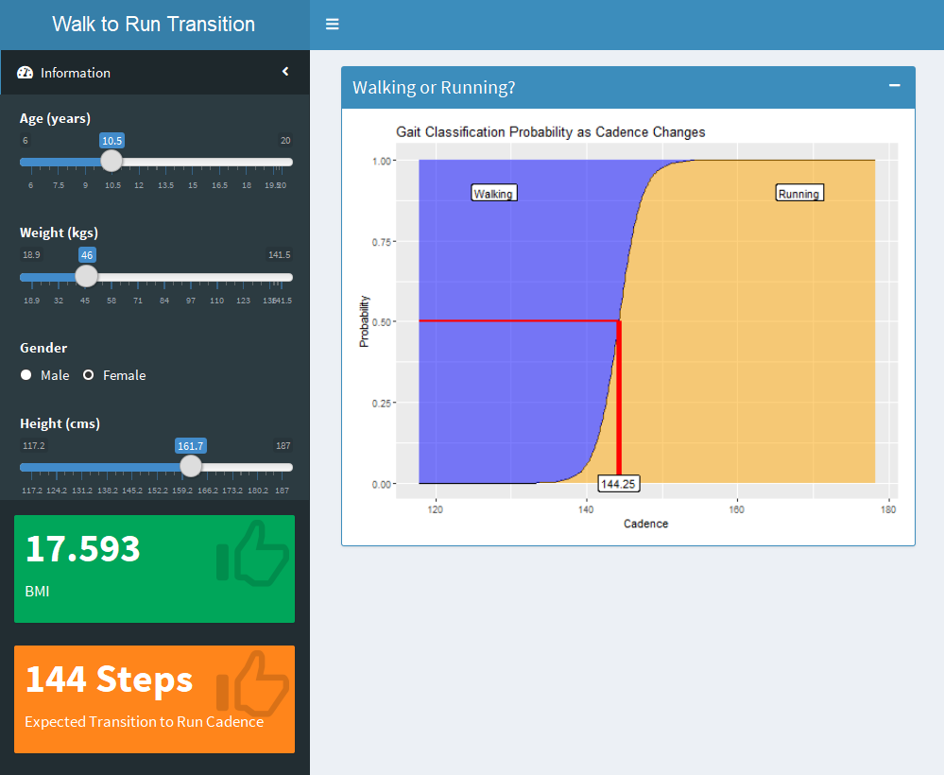

**Figure 1:** Screen shot of the R Shiny App. After user input (age, weight, height, gender), BMI (green) is displayed with expected walk-to-run transition cadence (orange). The graph on the right displays the probabilities associated with being in either gait classification.

# Discussion

The purpose of this study was to develop a model to predict age- and anthropometry-specific PTCs in individuals 6-20 years old. We hypothesized that cadence alone would reasonably predict the PTC across ages, and that the combination of cadence and leg length would provide sufficient information to accurately classify gait behavior. The results of the simple linear regression support the first hypothesis that cadence can autonomously be used to predict the PTC. In contrast to our hypothesis, the results of the multiple regression analysis revealed a simple mathematical equation can be used to estimate the PTC from age, height, mass, and BMIz. Moreover, the Shiny App herein provides researchers and clinicians with an easy tool to estimate the PTC for physical activity behavior assessment.

The independent variables selected for the final model were fortuitous with regards to application of this model to the general population. Three of the four variables used (age, weight, and height) are easily attained by any individual. The fourth variable, BMI z-score, can be calculated from the other three variables and the AGD package (Van Buuren, 2018) in R. This potential for application to the general population was the impetus behind creation of the Shiny app. In the development of this model, participants were not separated by sex. This exclusion was intentional, as observed sex-related differences in cadence in children are often negated when accounting for height or leg length.

Previous efforts to establish the walk-to-run transition based on walking speed have provide ample evidence that this threshold is between 2.0-2.2 m/s (e.g., 2.03 m/s (Shih, Chen, Lee, Chan, & Shiang, 2016), 2.06 m/s (Hreljac, 1995), 2.08 m/s (Ganley et al., 2011), 2.09 m/s (Diedrich & Warren, 1995), 2.10 m/s (Prilutsky & Gregor, 2001), or 2.21 m/s (Ranisavljev, Ilic, Soldatovic, & Stefanovic, 2014)). Moreover, speed-based transition thresholds (i.e., previously mentioned PTS) have been reported in children (Tseh, Bennett, Caputo, & Morgan, 2002). However, with respect to cadence, while previous research has indicated that the transition from walking to running occurs at a PTC ~ 140 steps/minute in adults, the study by Tseh and colleagues (2002) did not report on the PTCs for walking to running. To our knowledge, the study presented herein is the first to use cadence to predict the walk-to-run transition in children, adolescents, and young adults. The findings that cadence, height, and mass provide sufficient information supports the notion that this transition occurs based on anthropometric or mechanical constraints. However, future research may also expand to include other measures such as rating of perceived exertion, metabolic cost, mechanical work, or muscular efficiency.

**Conclusion**

Using standard demographic information (i.e., age, height, and mass), the cadence corresponding with the transition from walking to running can be accurately predicted in children, adolescents and young adults. This information is highly beneficial for individuals attempting to characterize locomotor behavior in the free-living setting. Moreover, herein we provide a free, user-friendly app that can be used by researchers or clinicians to determine an individual’s precise threshold without the need to incorporate the equation.

# Acknowledgements

The authors would like to thank Dr. William Johnson, X, Y and Z for the original conceptualization and development of this project, data collection and analyses at Pennington Biomedical Center. CADENCE-Kids was prospectively registered at ClinicalTrials.gov (NCT01989104). This work was supported by an award NIH NICHD 1R21HD073807 and in part by 1 U54 GM104940 from the National Institute of General Medical Sciences of the National Institutes of Health, which funds the Louisiana Clinical and Translational Science Center. These funding bodies had no role in design, in the collection, analysis, or interpretation of data, or in the writing or decision to submit the manuscript for publication. The content is solely the responsibility of the authors and does not necessarily represent the official views of the National Institutes of Health.

# Conflicts of Interest

The authors declare no conflicts of interest

# References

Alexander, R. M. (1989). Optimization and gaits in the locomotion of vertebrates. *Physiological Reviews, 69*(4), 1199-1227. doi:10.1152/physrev.1989.69.4.1199

Alexander, R. M. (2002). Energetics and optimization of human walking and running: the 2000 Raymond Pearl memorial lecture. *American Journal of Human Biology, 14*(5), 641-648. doi:10.1002/ajhb.10067

Diedrich, F. J., & Warren, W. H. (1995). Why change gaits? Dynamics of the walk-run transition. *Journal of Experimental Psychology: Human Perception and Performance, 21*(1), 183-202.

Ganley, K. J., Stock, A., Herman, R. M., Santello, M., & Willis, W. T. (2011). Fuel oxidation at the walk-to-run-transition in humans. *Metabolism, 60*(5), 609-616. doi:10.1016/j.metabol.2010.06.007

Hansen, E. A., Kristensen, L. A. R., Nielsen, A. M., Voigt, M., & Madeleine, P. (2017). The role of stride frequency for walk-to-run transition in humans. *Sci Rep, 7*(1), 2010. doi:10.1038/s41598-017-01972-1

Hreljac, A. (1993). Preferred and energetically optimal gait transition speeds in human locomotion. *Med Sci Sports Exerc, 25*(10), 1158-1162.

Hreljac, A. (1995). Determinants of the gait transition speed during human locomotion: kinematic factors. *Journal of Biomechanics, 28*(6), 669-677.

Li, L. (2000). Stability landscapes of walking and running near gait transition speed. *Journal of Applied Biomechanics, 16*(4), 428-435. doi:10.1123/jab.16.4.428

Minetti, A. E., Ardigo, L. P., & Saibene, F. (1994). The transition between walking and running in humans: metabolic and mechanical aspects at different gradients. *Acta Physiologica Scandinavica, 150*, 315-323.

Must, A., & Anderson, S. E. (2006). Body mass index in children and adolescents: considerations for population-based applications. *International Journal of Obesity, 30*(4), 590-594. doi:10.1038/sj.ijo.0803300

Noble, B. J., Metz, K. F., Pandolf, K. B., Bell, C. W., Cafarelli, E., & Sime, W. E. (1973). Perceived exertion during walking and running. II. *Med Sci Sports, 5*(2), 116-120.

Prilutsky, B. I., & Gregor, R. J. (2001). Swing- and support-related muscle actions differentially trigger human walk-run and run-walk transitions. *Journal of Experimental Biology, 204*(Pt 13), 2277-2287.

R Core Team. (2018). R: A language and environment for statistical computing. Vienna, Austria: R Foundation for Statistical Computing. Retrieved from <https://www.R-project.org/>.

Ranisavljev, I., Ilic, V., Soldatovic, I., & Stefanovic, D. (2014). The relationship between allometry and preferred transition speed in human locomotion. *Human Movement Science, 34*, 196-204. doi:10.1016/j.humov.2014.03.002

Shih, Y., Chen, Y. C., Lee, Y. S., Chan, M. S., & Shiang, T. Y. (2016). Walking beyond preferred transition speed increases muscle activations with a shift from inverted pendulum to spring mass model in lower extremity. *Gait & Posture, 46*, 5-10. doi:10.1016/j.gaitpost.2016.01.003

Tseh, W., Bennett, J., Caputo, J. L., & Morgan, D. W. (2002). Comparison between preferred and energetically optimal transition speeds in adolescents. *European Journal of Applied Physiology, 88*(1-2), 117-121. doi:10.1007/s00421-002-0698-x

Tudor-Locke, C., Schuna, J. M., Jr., Han, H., Aguiar, E. J., Larrivee, S., Hsia, D. S., . . . Johnson, W. D. (2018). Cadence (steps/min) and intensity during ambulation in 6-20 year olds: The CADENCE-Kids study. *International Journal of Behavioural Nutrition and Physical Activity, 15*(20).

Usherwood, J. R. (2005). Why not walk faster? *Biology Letters, 1*(3), 338-341. doi:10.1098/rsbl.2005.0312

Van Buuren, S. (2018). _AGD: Analysis of growth data_ (Version 0.38). CRAN: The Comprehensive R Archive Network. Retrieved from <https://CRAN.R-project.org/package=AGD>